Day 14 — DataFrame and Dataset

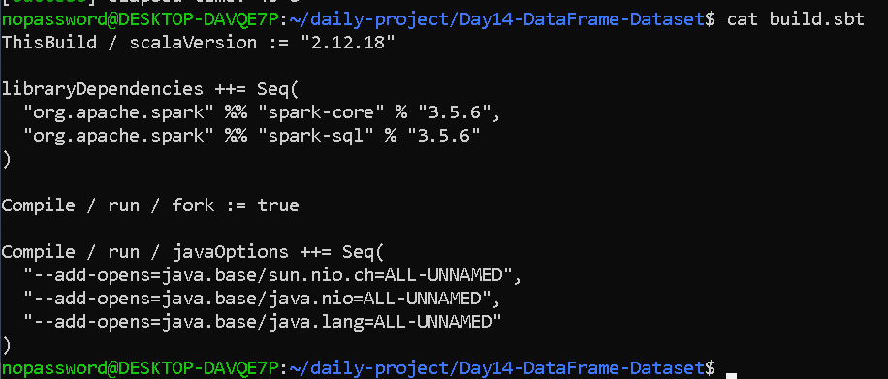

import org.apache.spark.sql.{SparkSession, DataFrame, Dataset}

case class Employee(
id: Int,
name: String,
department: String,
salary: Double
)

object EmployeePayroll {

def main(args: Array[String]): Unit = {

val spark = SparkSession.builder()
.appName("Employee Payroll Pipeline")
.master("local[*]")
.getOrCreate()

import spark.implicits._

// Employee data
val employees = Seq(
Employee(101, "Lisha", "IT", 50000),
Employee(102, "Arun", "HR", 45000),
Employee(103, "Priya", "IT", 60000),
Employee(104, "Rahul", "Finance", 55000),
Employee(105, "Anu", "HR", 48000)
)

// Create Dataset
val employeeDS: Dataset[Employee] =
spark.createDataset(employees)

println("=== Dataset ===")
employeeDS.show()

// Dataset -> DataFrame
val employeeDF: DataFrame =
employeeDS.toDF()

println("=== DataFrame ===")
employeeDF.show()

// Filter
val highSalaryDF =
employeeDF.filter($"salary" > 50000)

println("=== Employees with Salary > 50000 ===")
highSalaryDF.show()

// DataFrame -> Dataset
val employeeDS2: Dataset[Employee] =
employeeDF.as[Employee]

println("=== DataFrame converted back to Dataset ===")
employeeDS2.show()

// Payroll calculation
val payrollDS = employeeDS.map { employee =>
val annualSalary = employee.salary * 12

(
employee.id,
employee.name,
employee.department,
employee.salary,
annualSalary
)
}

println("=== Employee Payroll ===")
payrollDS.show()

// Department-wise salary
val departmentSalary =
employeeDF
.groupBy($"department")
.sum("salary")

println("=== Department-wise Salary ===")
departmentSalary.show()

spark.stop()
}
}

OUTPUT—

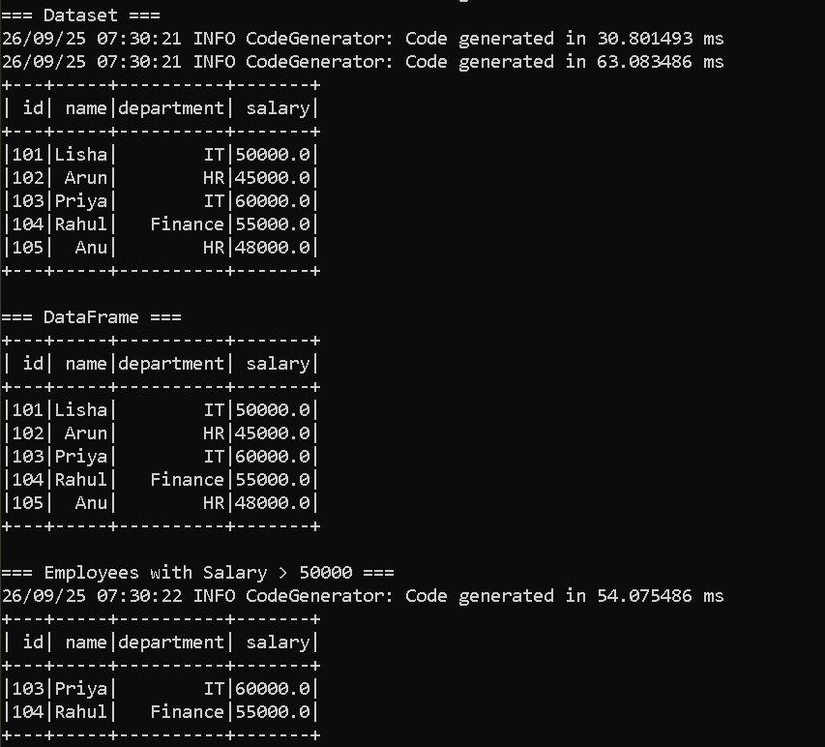

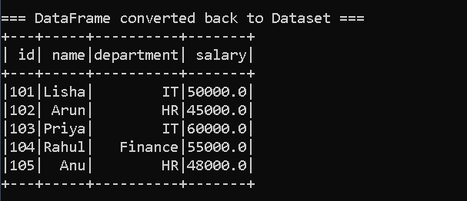
=== Employee Payroll ===
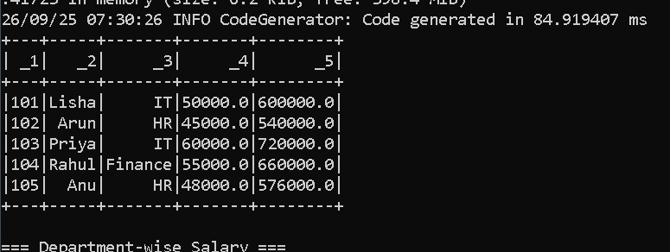

=== Department-wise Salary ===
